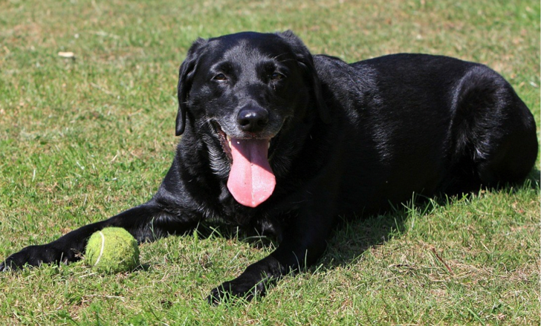



Looking for Dogs with Laryngeal Paralysis

Studying pacemakers as an innovative treatment
for laryngeal paralysis in dogs
The Study
The goal of this study is to determine if a laryngeal pacemaker can adequately stimulate the muscles of the larynx in dogs with idiopathic laryngeal paralysis as a potentially new form of treatment.

Who Qualifies?
Any dog with idiopathic laryngeal paralysis that is undergoing our standard of care surgical treatment - unilateral arytenoid lateralization (tie-back) - would be a candidate for this study.

What Happens?
At the time of surgery tie-back surgery, dogs will undergo stimulation of the laryngeal muscles with a laryngeal pacemaker to evaluate the response and feasibility as a potential new option for treatment of idiopathic laryngeal paralysis. The muscle evaluation takes approximately 5 minutes and will not impact the traditional tie-back surgery or any of the postoperative care.

Why Participate?
Participation will help us determine if laryngeal pacing is feasible in dogs as a potentially more physiologic form of treatment compared to the conventional tie-back procedure. In appreciation for your participation financial incentive is provided to help reduce the cost of the tie-back procedure.

More Information
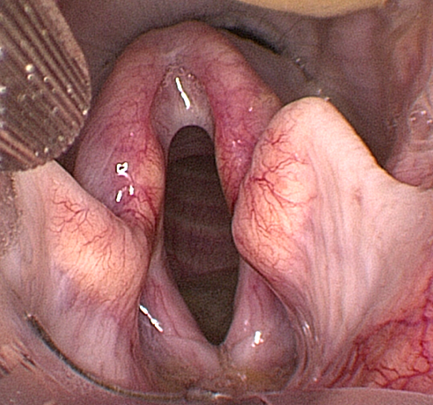
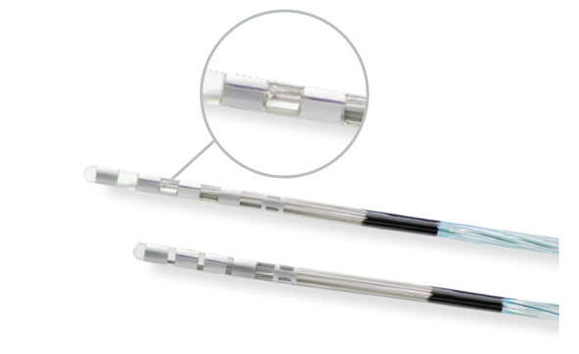

If you are interested in participating in this study, please contact the General Surgery Service at 608-263-7600.

